# Varun Mannam: [vmannam@nd.edu](mailto:vmannam@nd.edu) (University of Notre Dame)

Instructions to run the image denoising Fiji/ImageJ plugin. (includes installation of the TensorFlow manage site)

Steps:

1. Fiji -> Help -> Update -> ImageJ updater -> Manage update sites

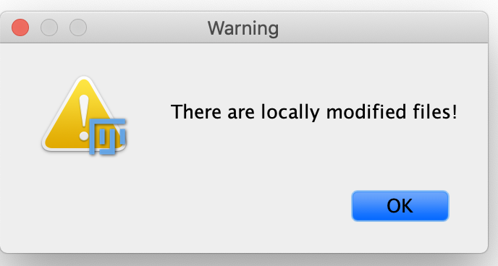

Press -> "OK"

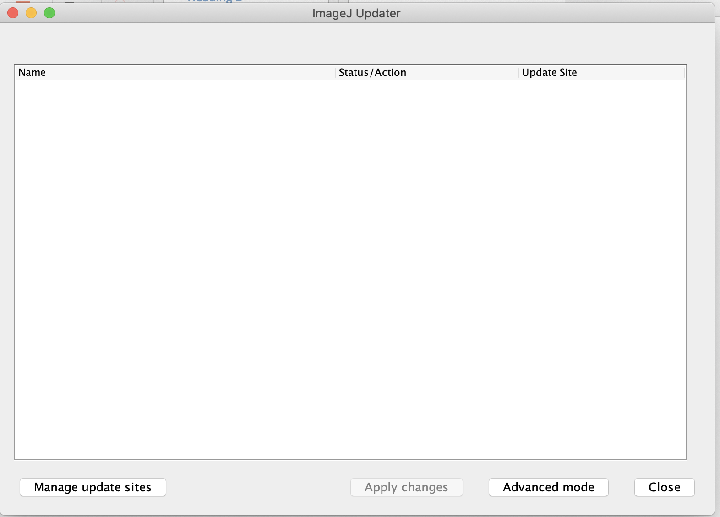

1. Goto Manage update sites ->

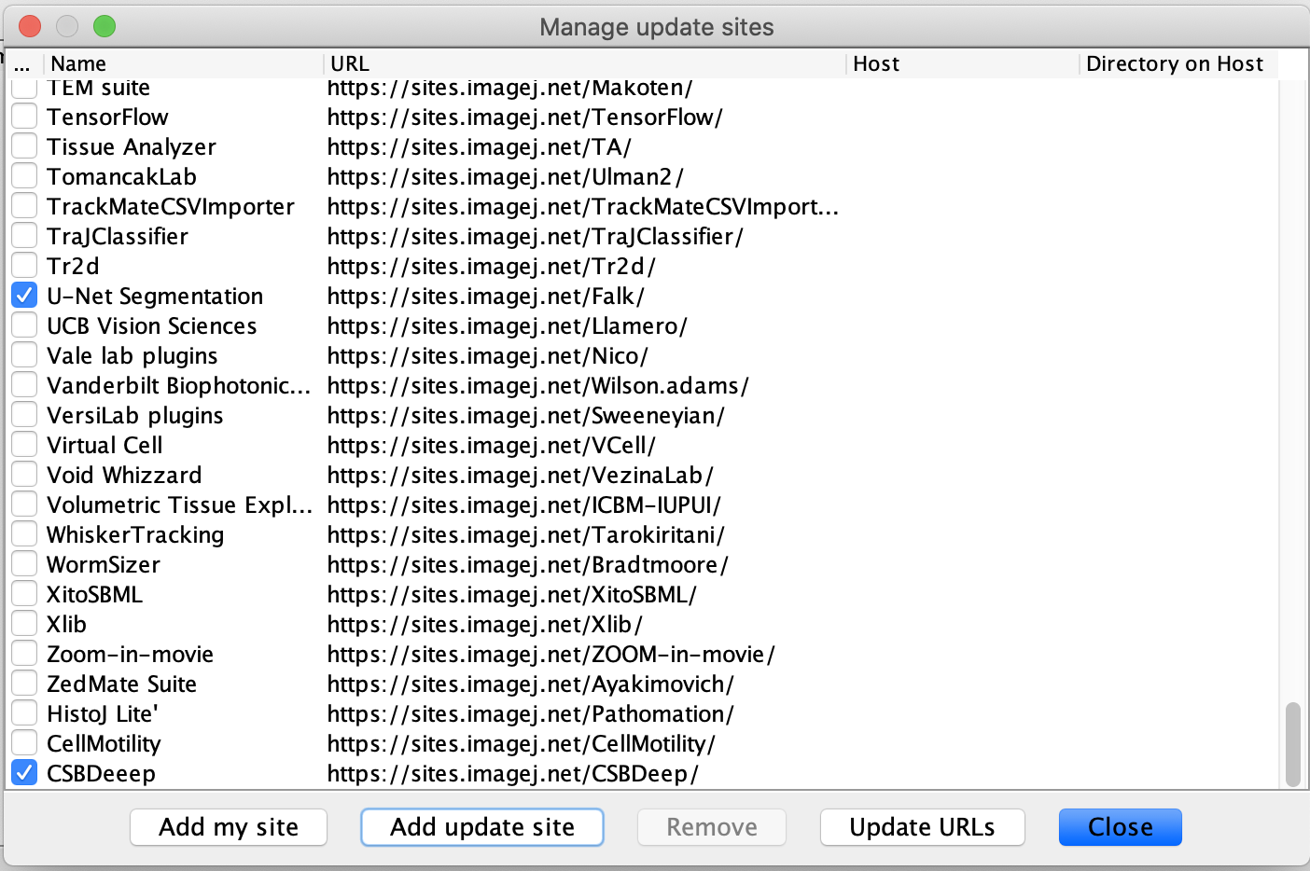

search for the site with Name: TensorFlow and URL is <https://sites.imagej.net/TensorFlow/>

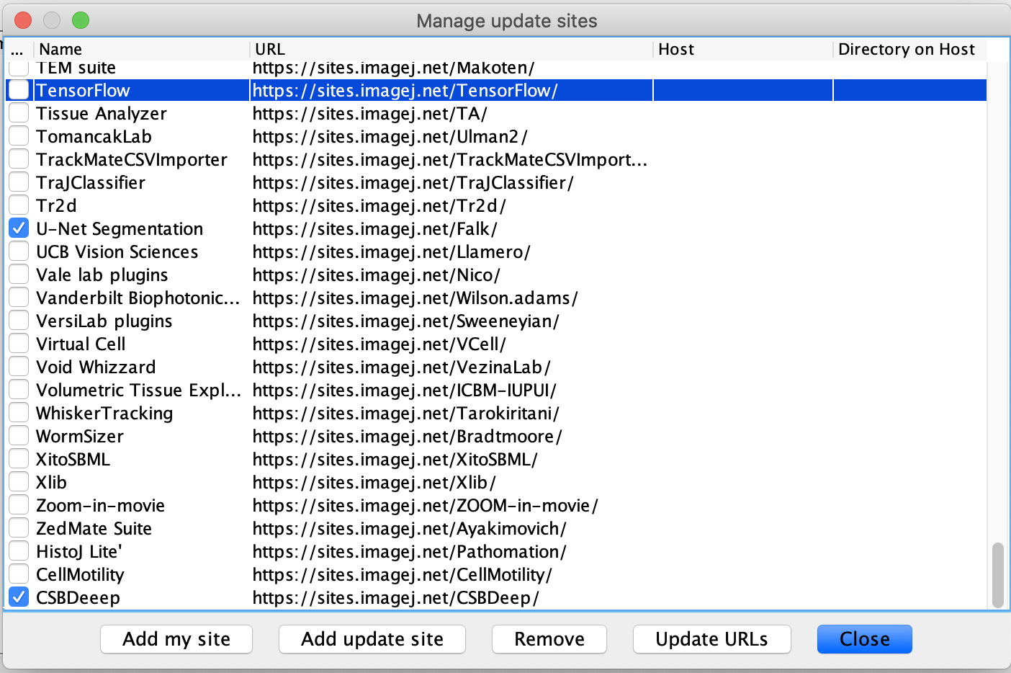

1. Select TensorFlow site.

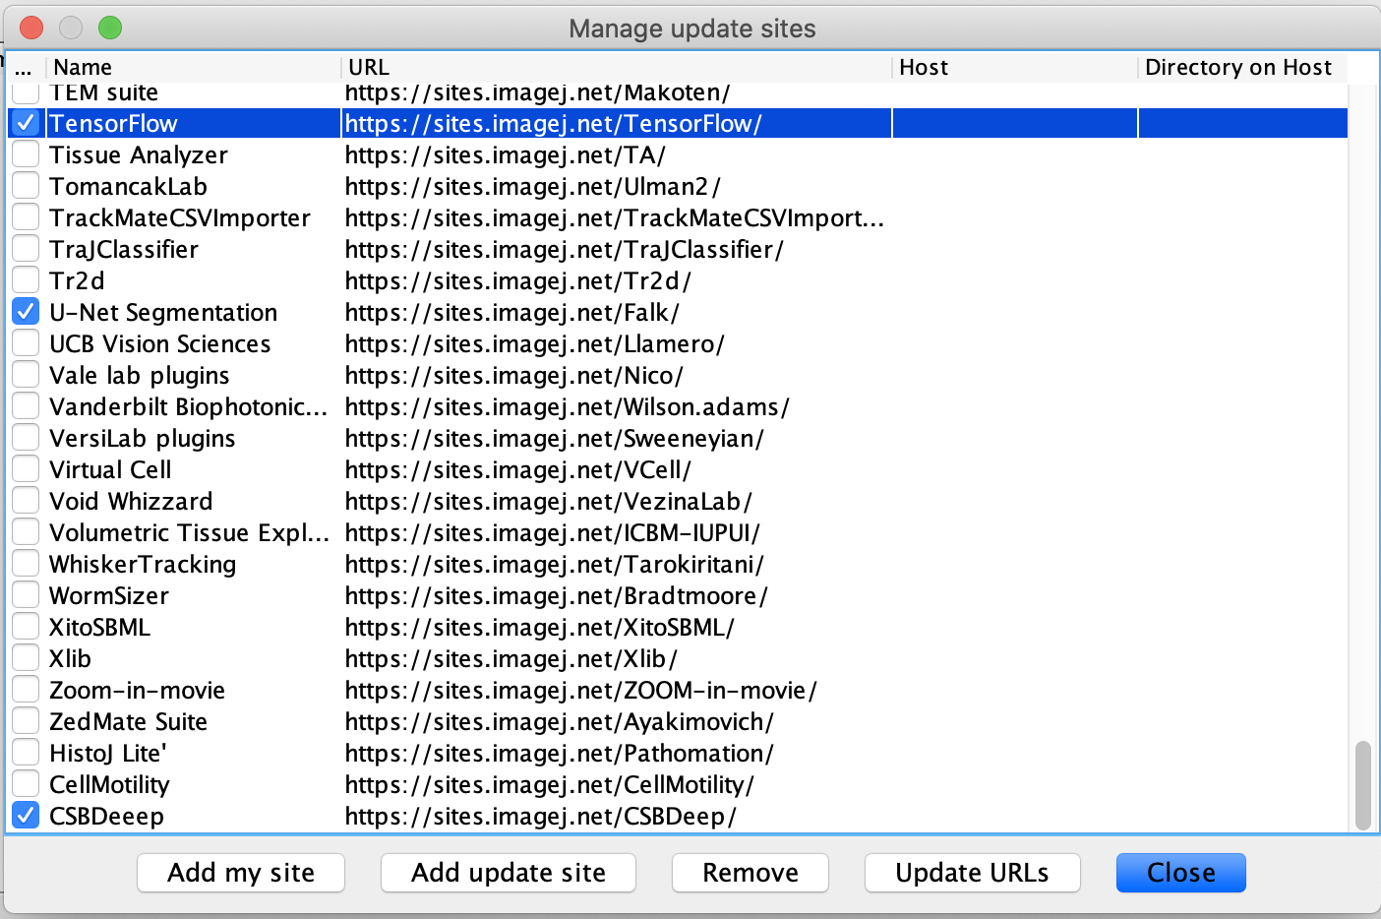

Press -> "Close"

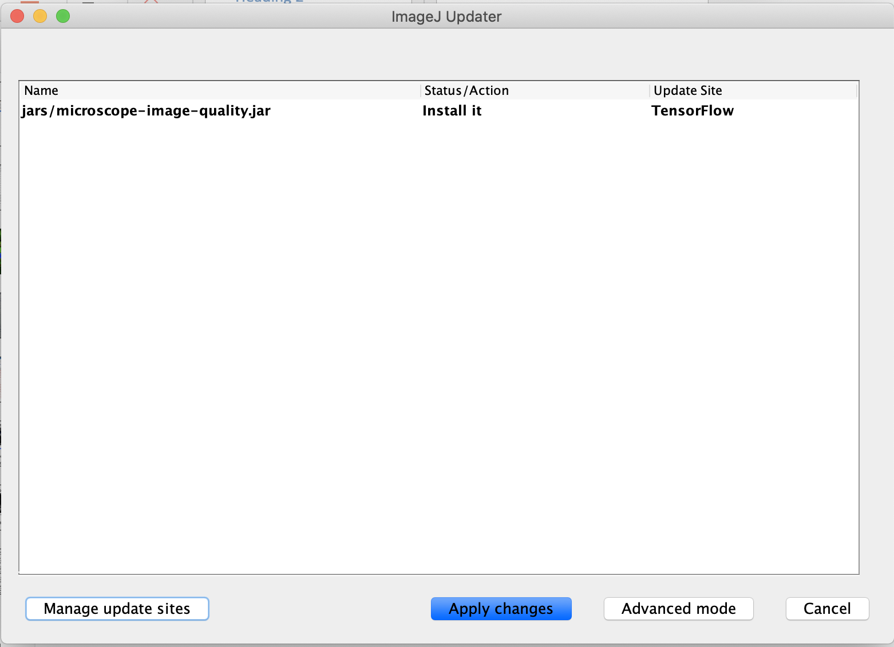

Press -> "Apply changes"

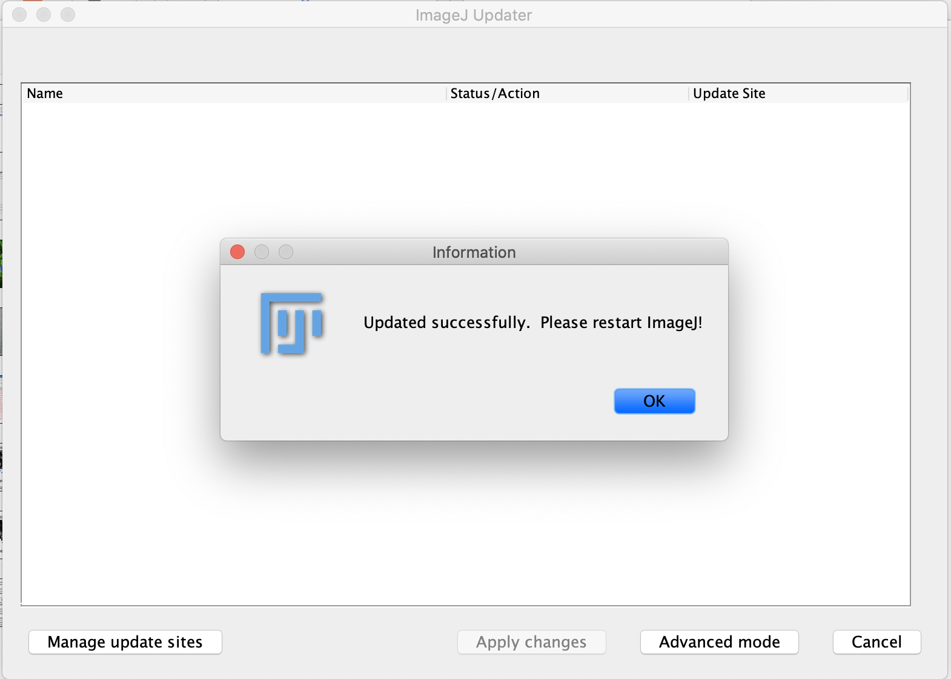

Press -> "OK"

1. Restart the Fiji/ImageJ -> You can see the TensorFlow in the following section
2. Fiji -> Edit -> Options -> TensorFlow

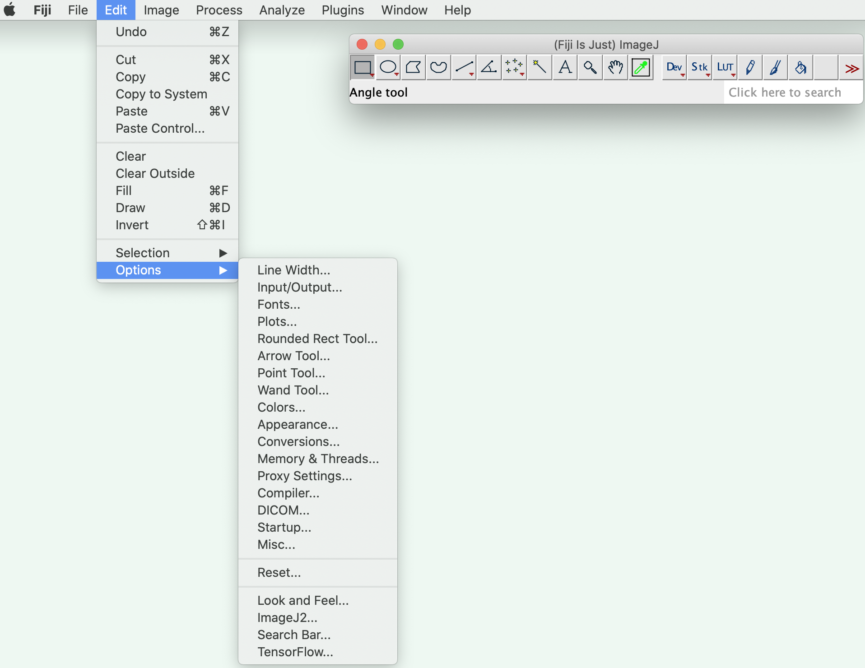

Select TensorFlow here. We will get a new pop-up

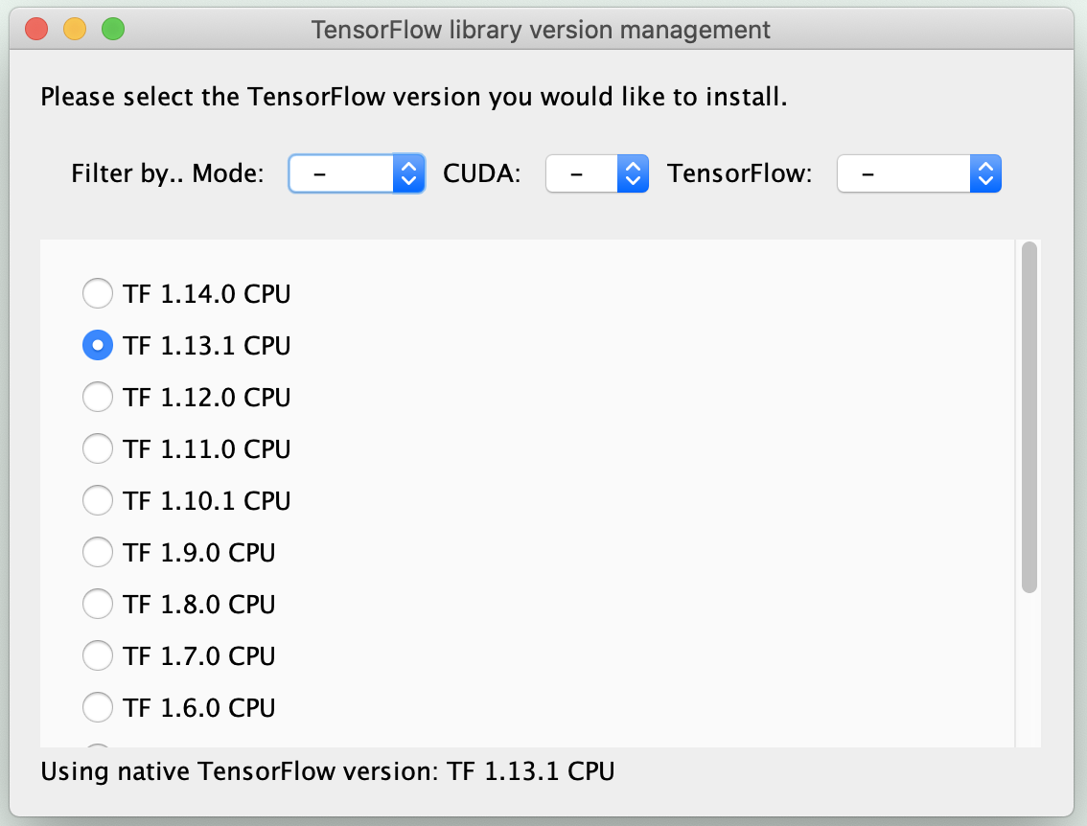

Select TF version as either TF 1.12.0 or TF 1.13.1 for CPU processing and choose the proper TensorFlow version based on Mode (either CPU/GPU), CUDA (driver version based on CUDA and CuDNN) and TF version

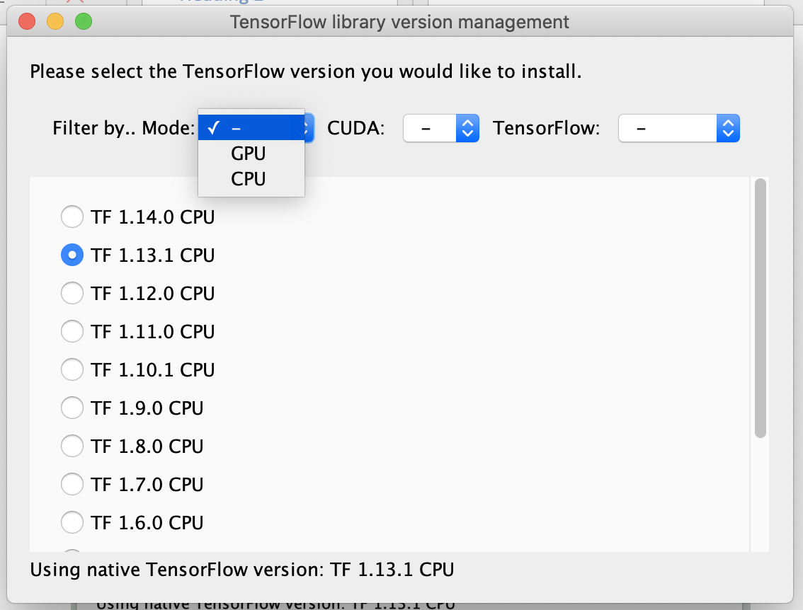

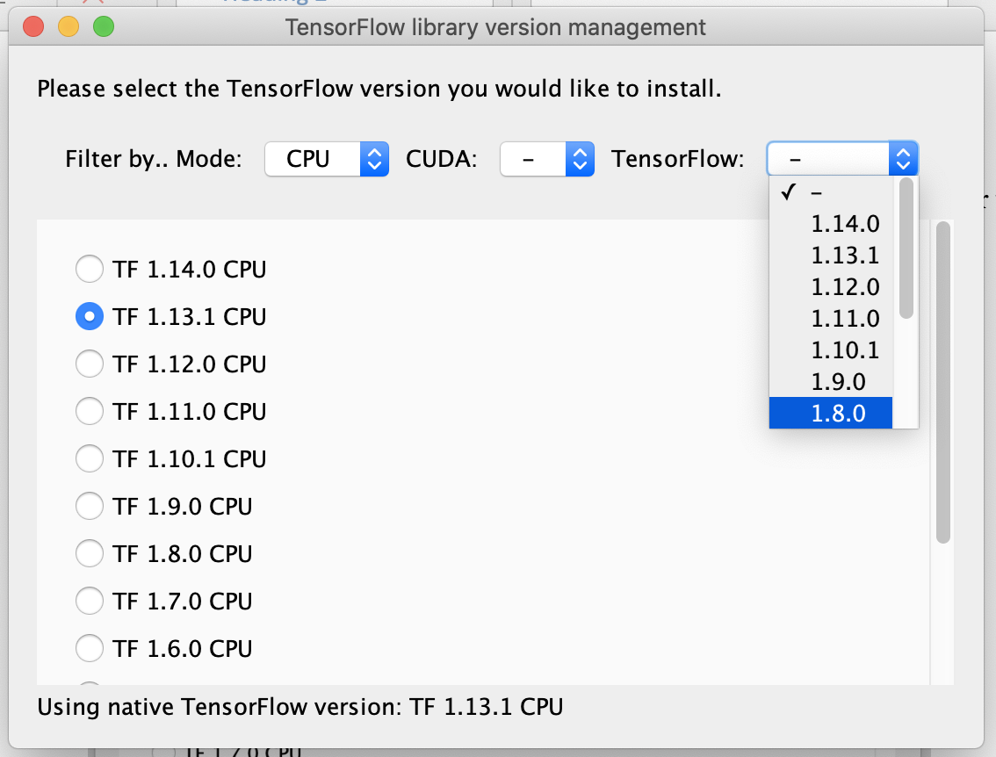

Note: Mac only support TF CPU version only.

in Linux/Windows machine with GPU:

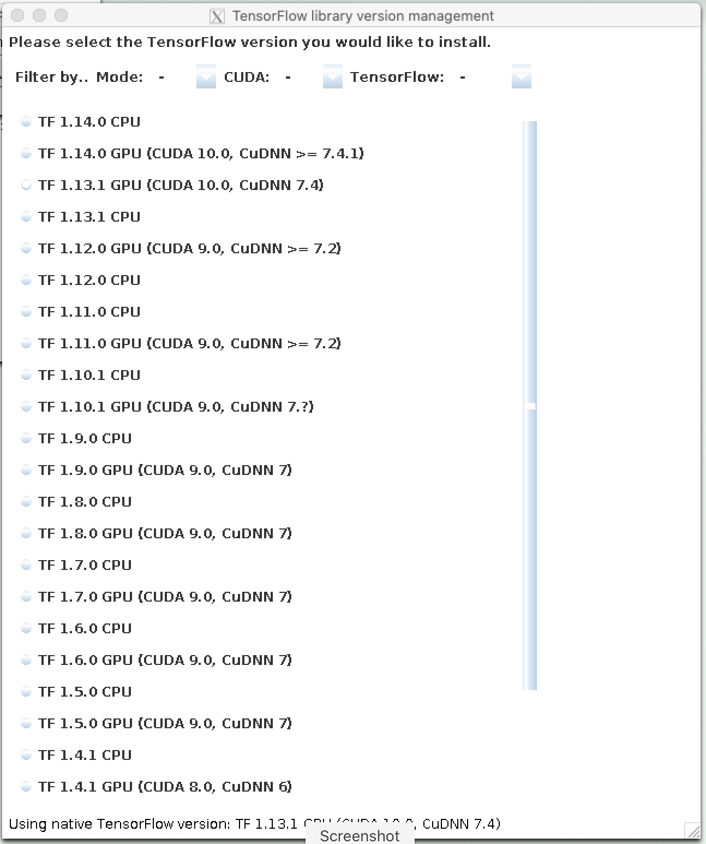

Select the combination of TF GPU CUDA and CuDNN drivers combination to get the correct TF version.

For image denoising using U-Net deep neural network inference model.

1. Install the Image denoising plugin from the GitHub location

<https://github.com/ND-HowardGroup/Instant-Image-Denoising/tree/master/Plugins/Image_Denoising_Plugins_Journal/Plugin_Targets>

Either place this .jar file in the Fiji -> Plugins location

example: Fiji installed location

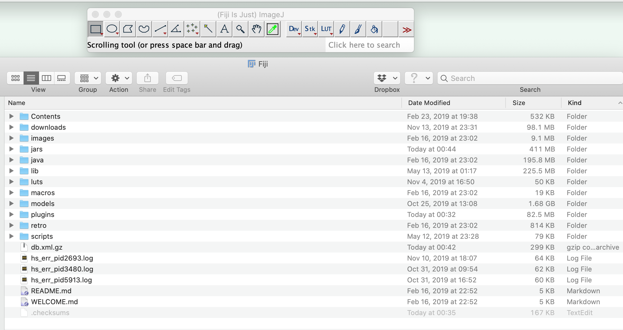

or Install this downloaded plugin directly in Fiji.

Fiji -> Plugins -> Install Plugins



select the downloaded ImageJ jar file folder location

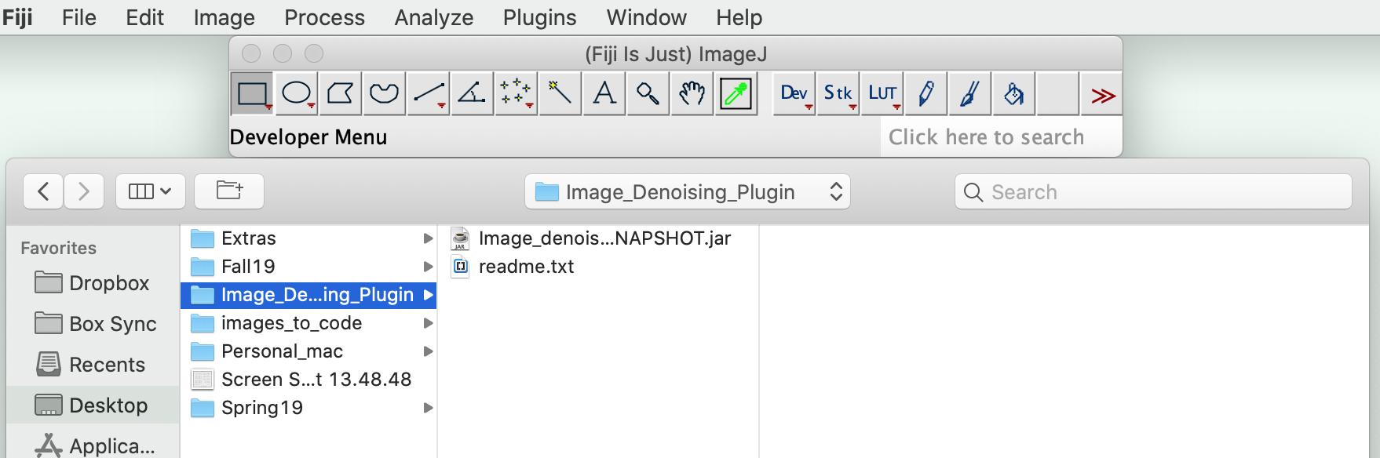

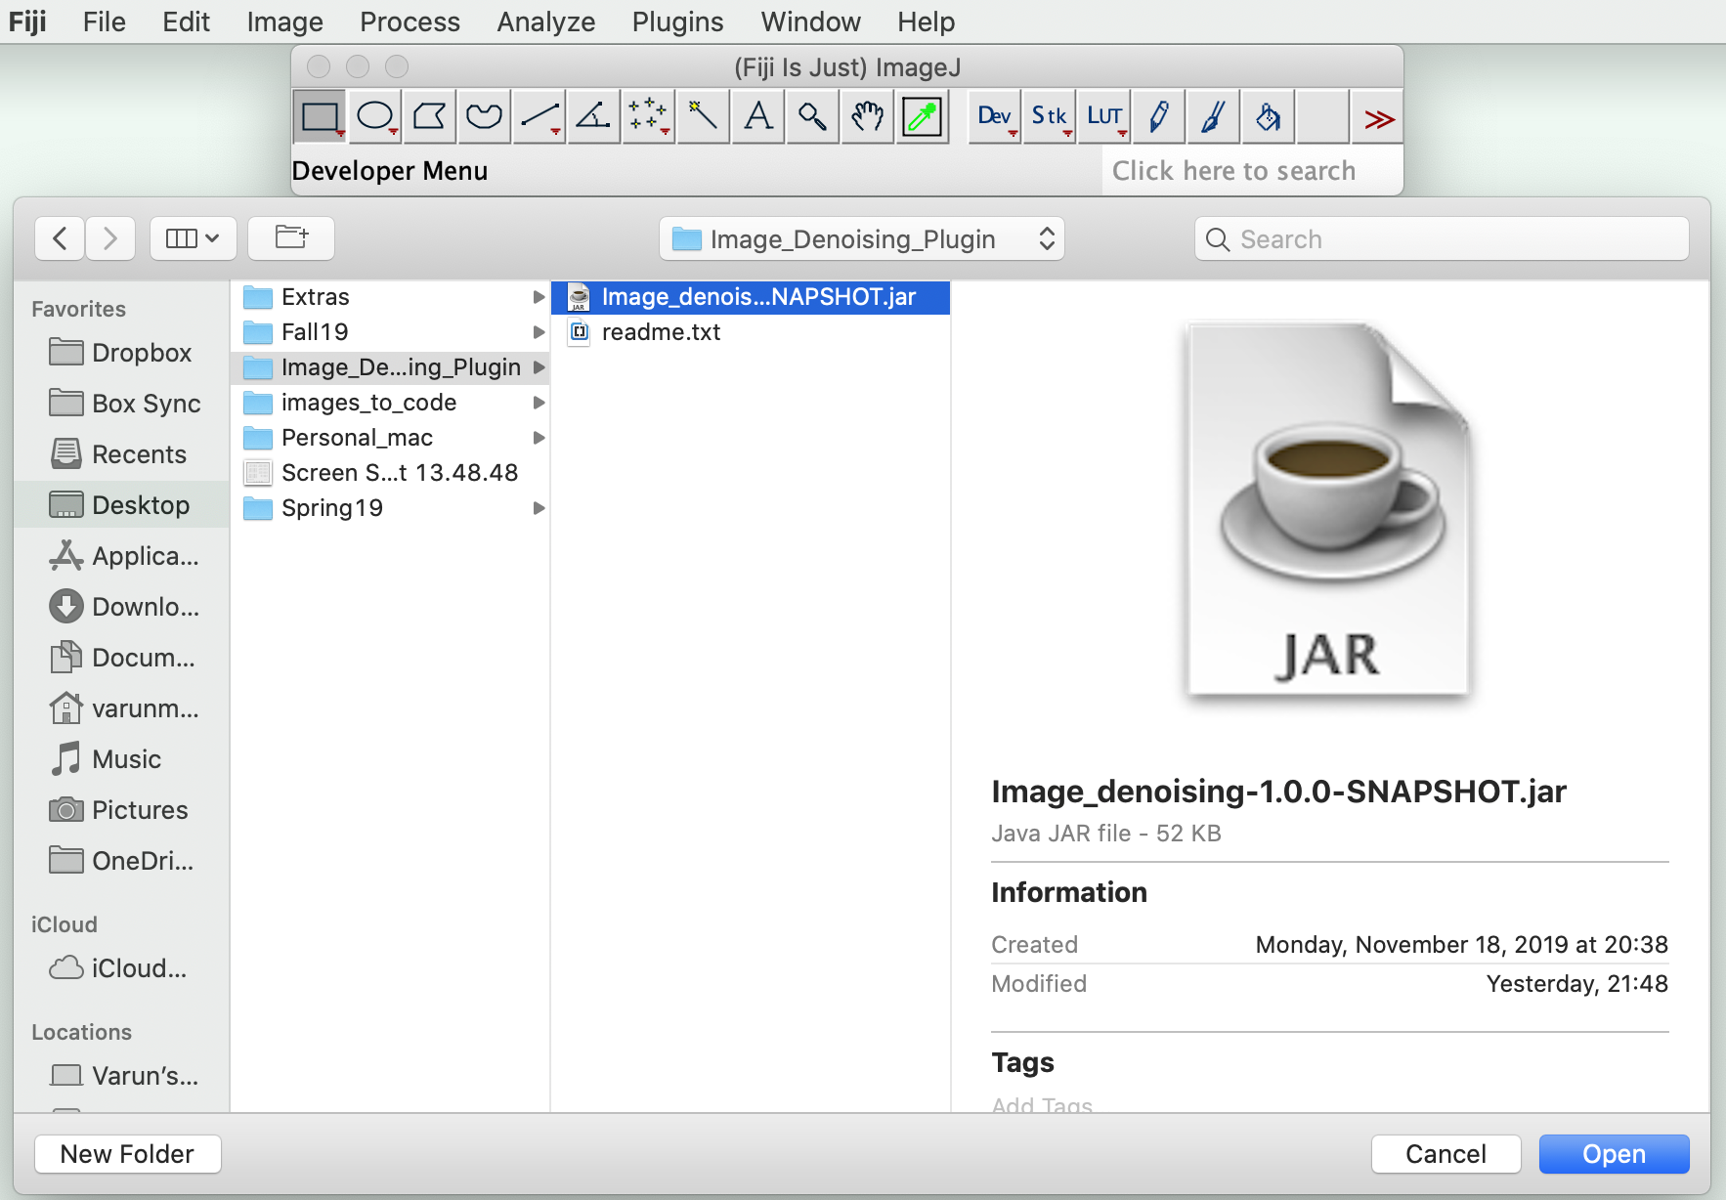

Press -> "Open"

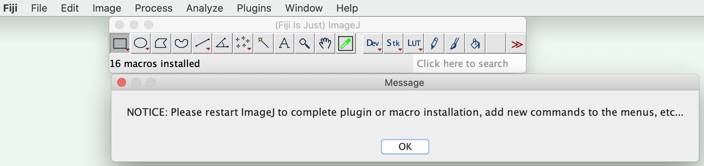

Press -> "OK"

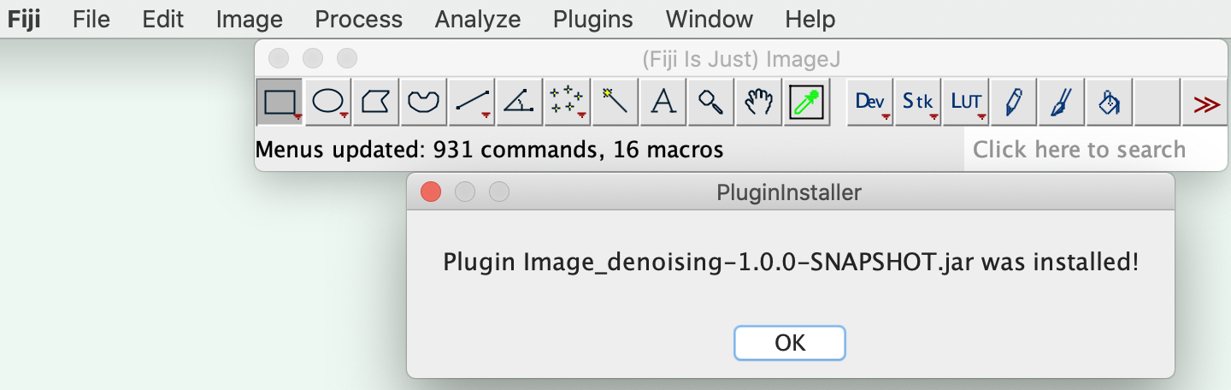

Press -> "OK" and restart the Fiji.

After restart of Fiji, now you can see the image denoising plugin in the Plugins section.

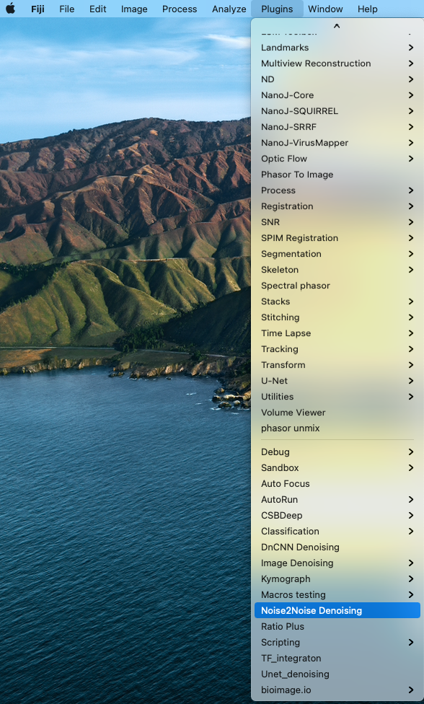

location: Fiji -> Plugins -> Noise2Noise Denoising or Fiji -> Plugins -> DnCNN Denoising.

Use the search section to get this plugin.

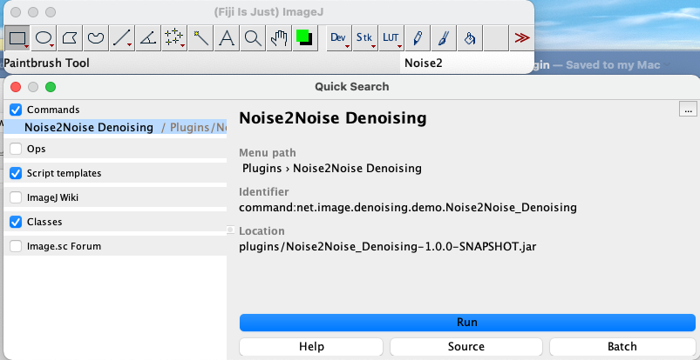

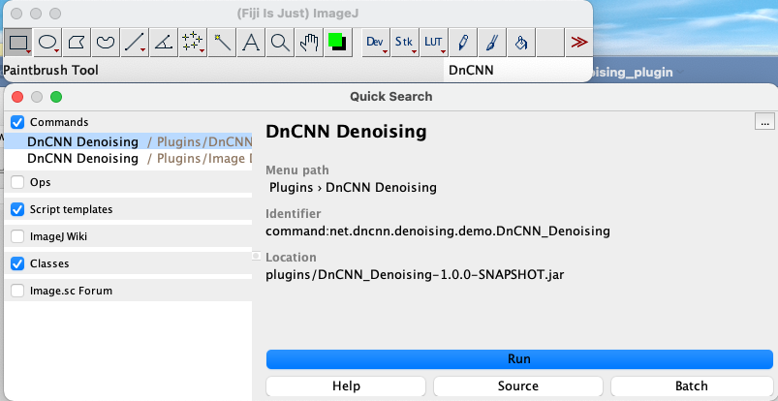

To test image denoising plugin:

Select an image in Fiji

Now run this plugin Noise2Noise Denoising or DnCNN Denoising plugin.

Example:

2D gray scale noisy microscopy image

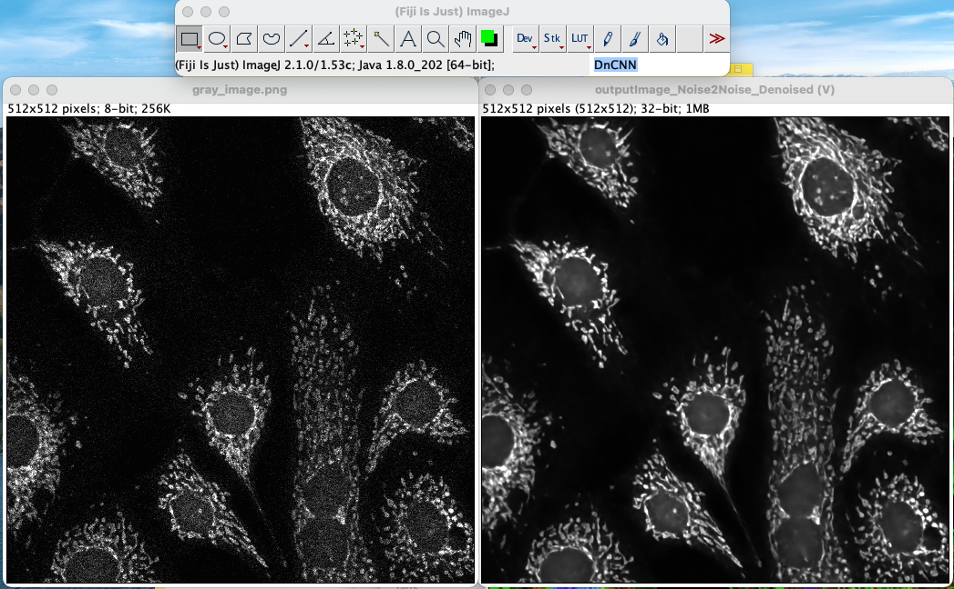

Adjust the brightness of the noisy input and denoised output image and input noisy image to see the clear difference between the noisy input and denoised outputs.

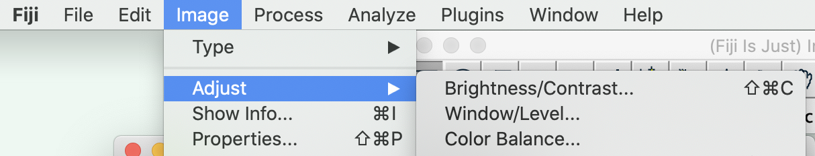

Now we can see the difference between noisy input and denoised output images

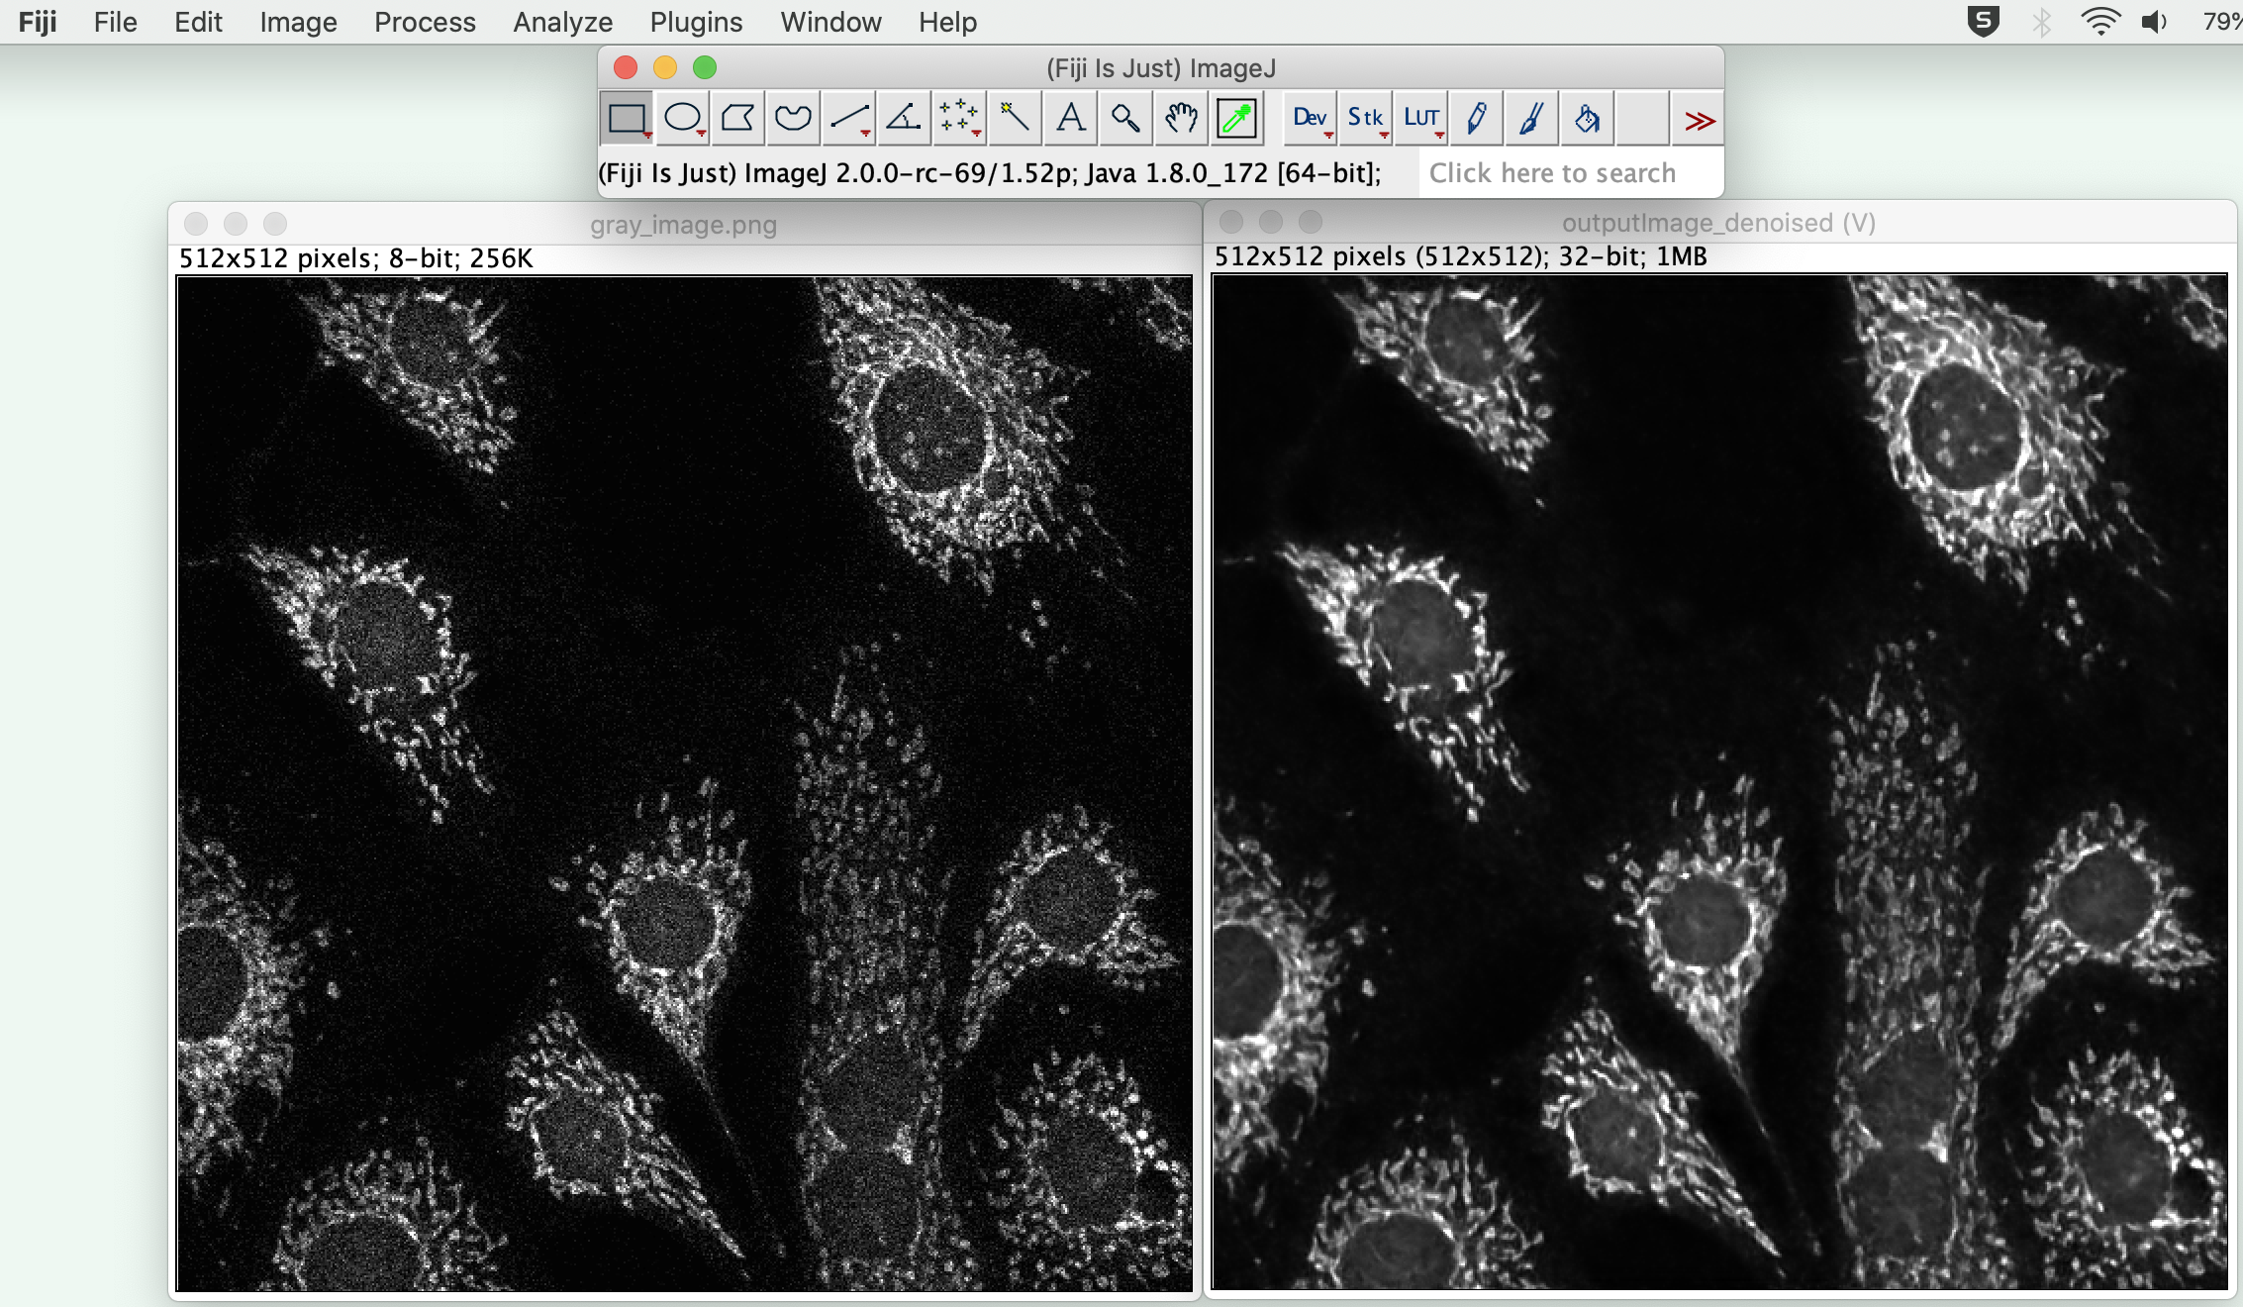

**Note**: output of denoised image is always 32-bit format (can convert to 8-bit images prior to any further processing) and for color images, we need to separate the images from denoised output stack (stacks -> split channels) and merge them later (image -> color -> merge channels) to form a color image.

**Example**: for a color image:

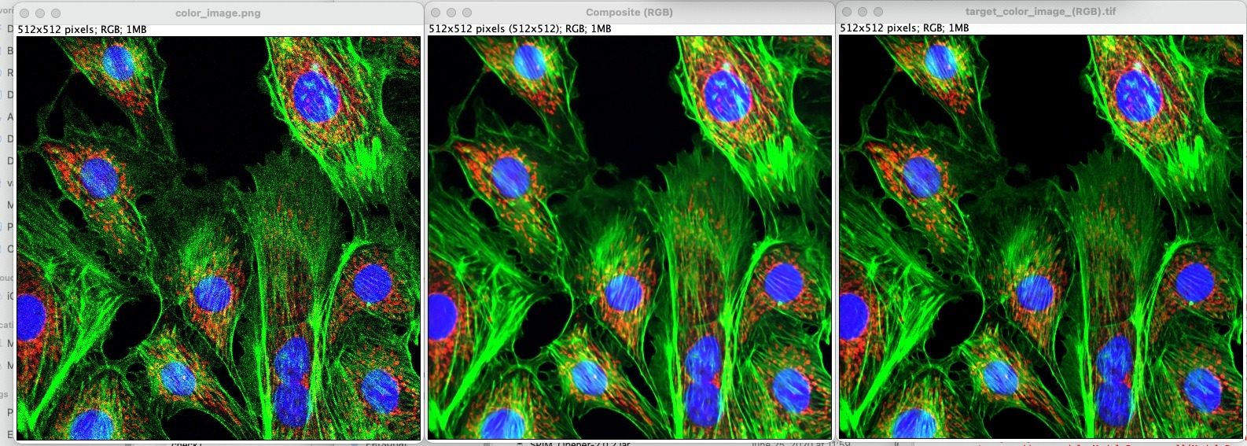

Left to right: Noisy color image (contains 3 channels), Denoised color image (using Noise2Noise denoising plugin) and ground truth image.